BUSINESS AND INVESTORS INCENTIVES – APPLICATION FORM
Complete this application form with reference to the Business and Investors Incentives Policy
Applicants Information
Business Name
Business Address
Business Owners Names
(list all owners names)
Phone / Mobile Numbers
Email Address
Business Type | Existing Business New Business
Business Tier - (Refer to Policy)
Tier Type | Tier 1  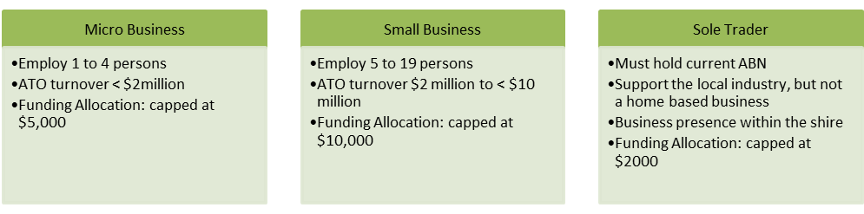  Tier 2 - Medium Business Large Business  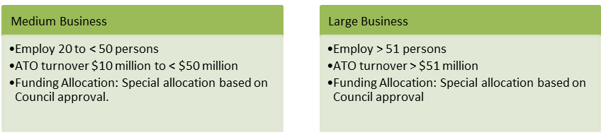
Eligible Tasks
Proposed Type of Works (place a tick in applicable Box) | Upgrade Shop Front Structural Upgrade Driveways  Council Product Billboard & Signboards IT Equipment Marketing  Office Furniture Website Other (please state):
Scope of Works or Expression of Interest
(Description of works to be completed – supporting documentation must be attached to application, as per Business and Investors Incentives Policy eg: Quotes/plans/drawings/contract)

Certified Builder / Repairers / Contractor / Supplier Details
(Name and Address – If Owner Builder permit must be provided)

Start Date and Expected Finish Date | Start: Finish:
Total Cost of Build, Repairs, Upgrade or Set-up
Completion of Approved Works
Upon Completion of Approved Works, you must provide Council with the necessary documentation | As listed in the Business and Investor Incentives Policy.  Example:  - Form 21 – Final Inspection Certificate  - Confirmation by the Builder, Contractor or Tradesperson  - Fully Paid Invoice and Receipt from Supplier who completed/supplied approved works  - Any other required documentation
Payment of Business and Investors Incentives Monies
Upon receipt of all required Completion of Approved Works documentation, Council will complete the approval process and make payment of Invoice for Grant Approval Amount, as provided by Business applicant.
Signature of all Applicants Required | I/we make this application to the Business and Investors Incentives Program and declare that all the information included in this application is true and correct.  Signature (1) ……………………………………………….. Date:  Name of Applicant: ………………………………………….  Signature (2): ……………………………………………….. Date:  Name of Applicant: ………………………………………….
Office Use Only
Application Received by | Date:
Assessment of Application – ESO |  |  | Date |  | Comment
Has confirmation of Business Details been confirmed – ABN Search etc
Does the Applicant/s own the property where the work will be completed
Does the Application meet the Eligibility Check
Does the work meet the Approved Scope of Works
Has the required Documentation been provided, as per policy – List in comments
Recommendation to CEO
Continue to Financial assessment
Assessment of Financial Capacity – Tier 2 businesses (building works only) – CEO to Assess
Has Trading Figures for 3 years been provided
Does Trading Figures support the contribution
CEO – Approve or Decline
Signature: |  |  | Date: |  | Approve Decline
Approval Letter
Approval / Decline Letter sent to applicants |  |  | Date: |  | Name:
Completion of Approved Works
Program funds are payable when required documentation is received by Council (refer to Business and Investors Incentives Policy)
List Documentation Received from Applicant:

Does Documentation meet the application Requirements | Yes or No | Date |  | Comments
ESO | Yes No
CEO | Yes No
Approved for Payment of Grant Funds
Approved by | Name:  Position:  Signature:  Date:
Payment of Invoice provided by Business
Invoice processed | Date:
Completion Letter
Approval / Payment Letter send to Applicants | Date: Name:

